Discussion Forum

Database name : qanda

Tables:

1. user

Columns:

u_id

u_name

u_fname

u_lname

u_email

u_pwd

2.question

Columns:

q_id

q_title

q_tags

q_desc

user_u_id

3.answers

Columns:

a_id

a_desc

user_u_id

question_q_id

MicroServices Available:

1.authentication-user-service

2.question-answer-service

3.eureka-discovery-service

4.zuul-gateway-service

Features:

<http://localhost:8083/authentication-service/authenticate> -with zul

<http://localhost:8088/authenticate> - without zull

1.Sign Up

* To sign up the user has to enter his Firstname,Lastname,Username,Email and password

At back end we check if that particular username exists or not using usernameAlreadyExistsException

*When users signup password is also encrypted for security purpose at the backend so only this encrypted password gets stored at the database.

2.Login

While logging in user has to enter the username and password. If the given information is valid or not is checked in the authentication function.

If not valid the user is not allowed to enter the application.

Api : <http://localhost:8088/authenticate>

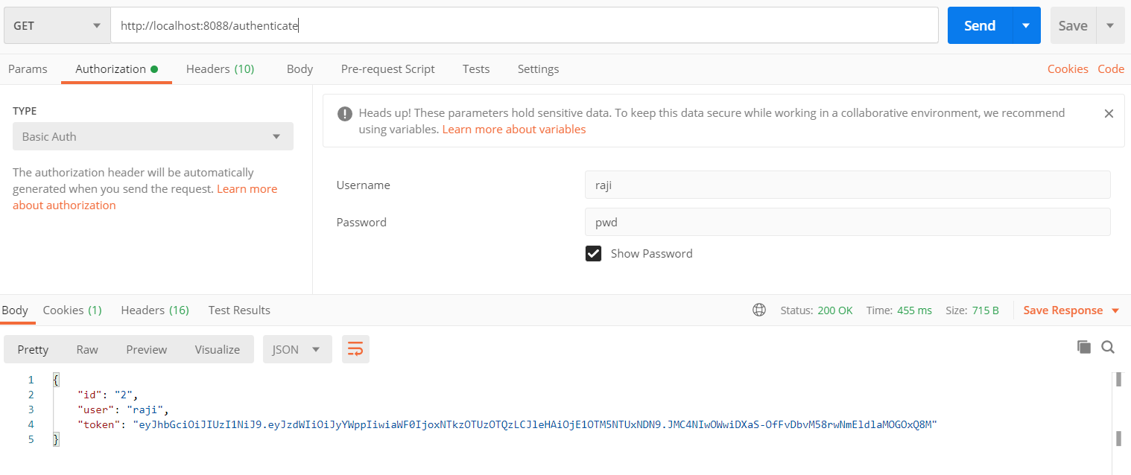

3.Create a new question

For this in QuestionController createQuestion() -> fuction question object is passed from front end , and this object is saved into the database with the help oj JPA Repository

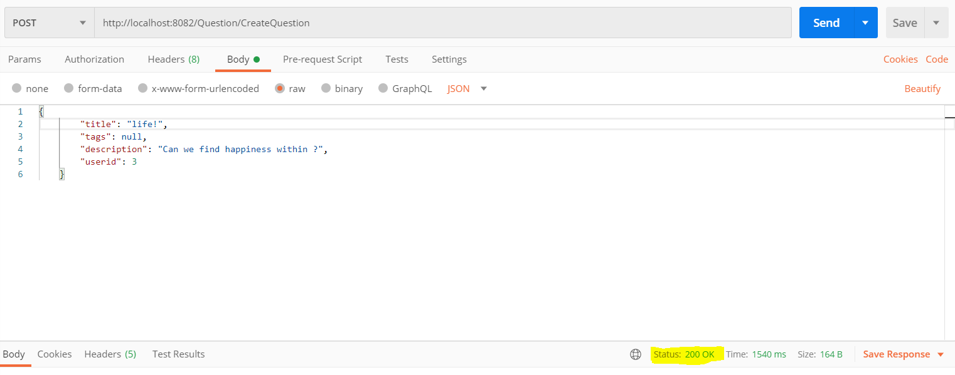

4.To view All Questions

This is achieved by getAllQuestion() in QuestionController Where this is a get request so it returns a list of all questions.

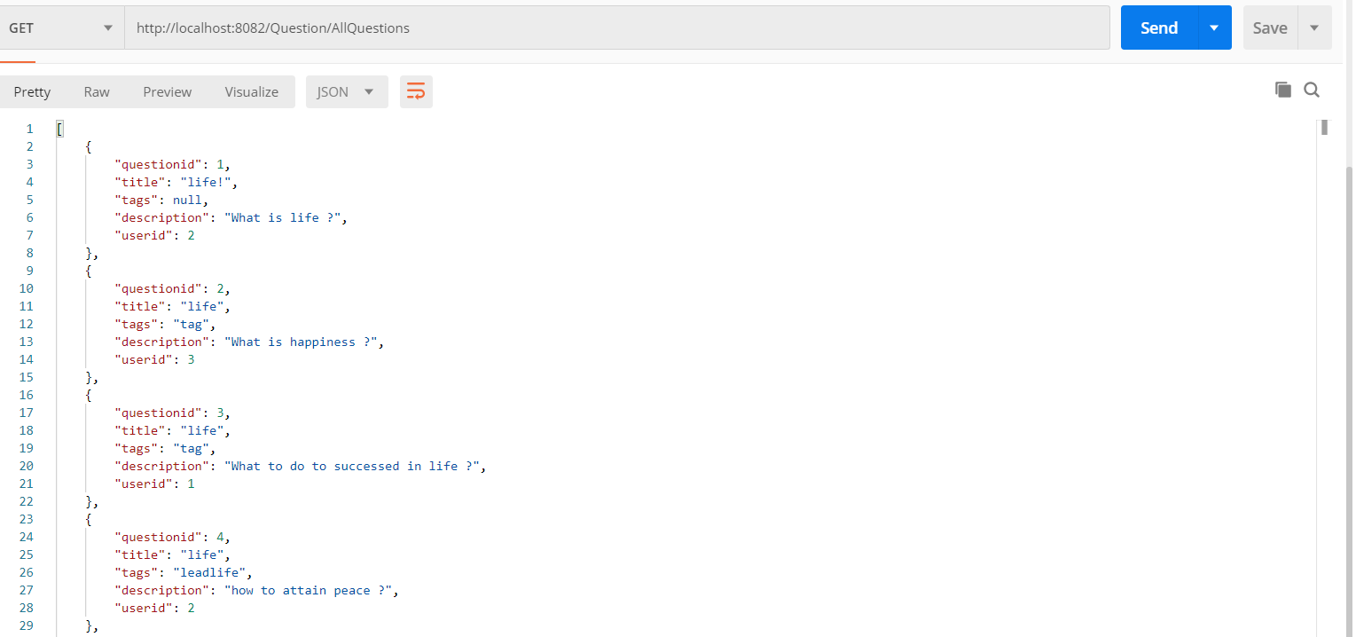

5.To Update an existing question

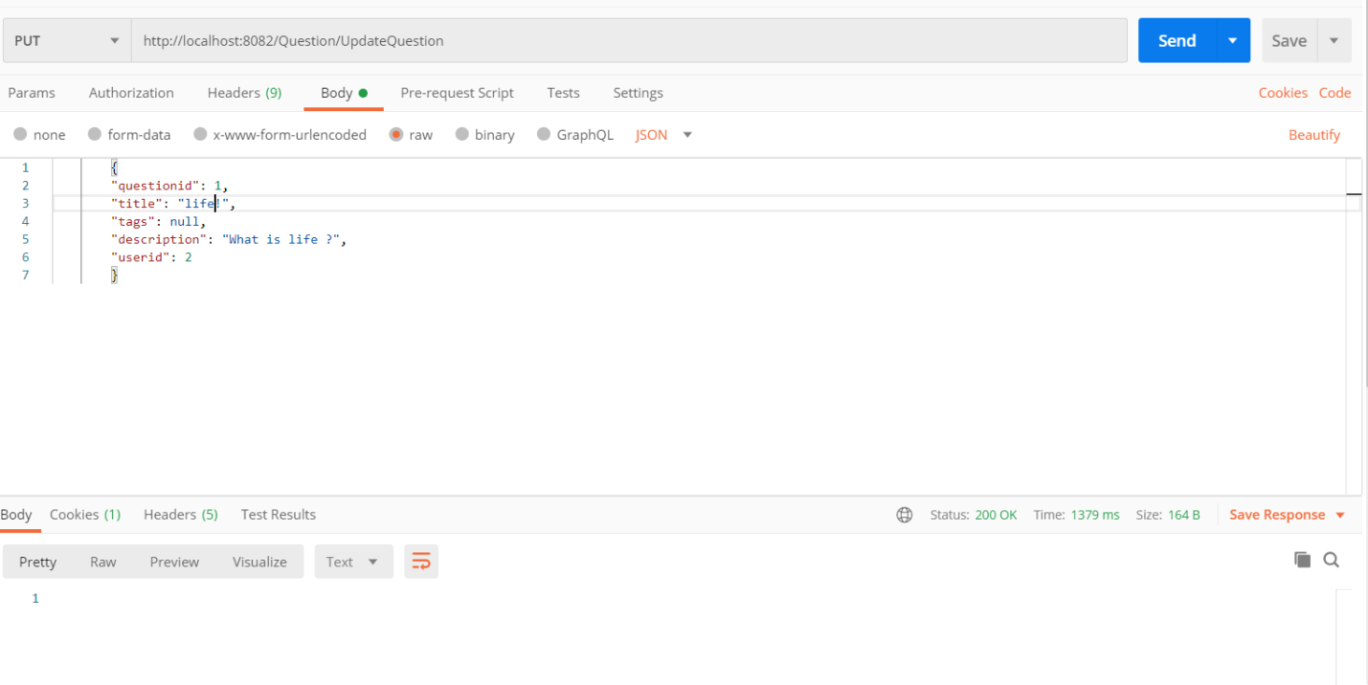This is done by updateQuestion() in QuestionController where the question that needs to be updatted is sent from the front end as an object , which is modified using update query in the repository

6.To get Answers for a particular question

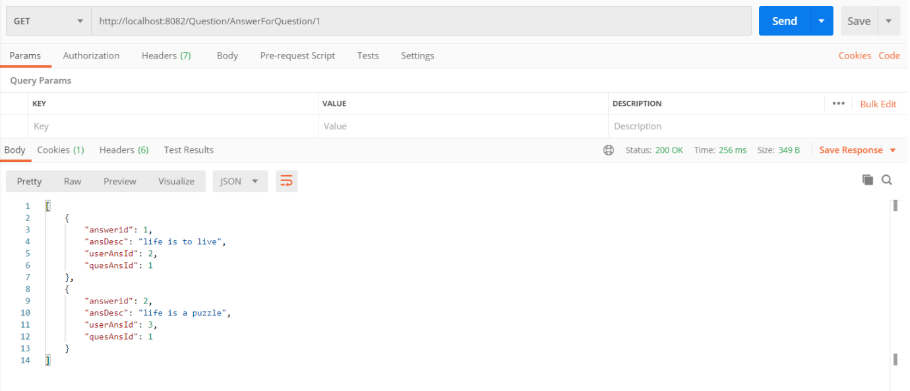This is done by getAllAnswersByQid() in QuestionController where from the front end the id of that particular question has to be passed and it’s respective answers are returned as a collection to the front end .

7. Delete a question

To delete a question, id of that particular question is passed from the front end ,then that id’s detail is deleted.

AnswerController

1. To get all answers

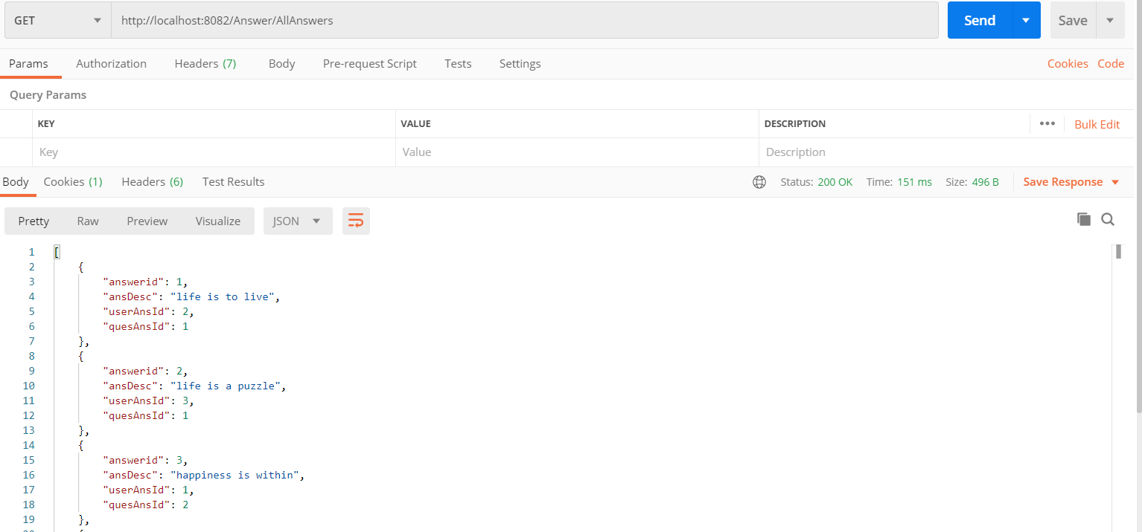

2.To Post a new answer

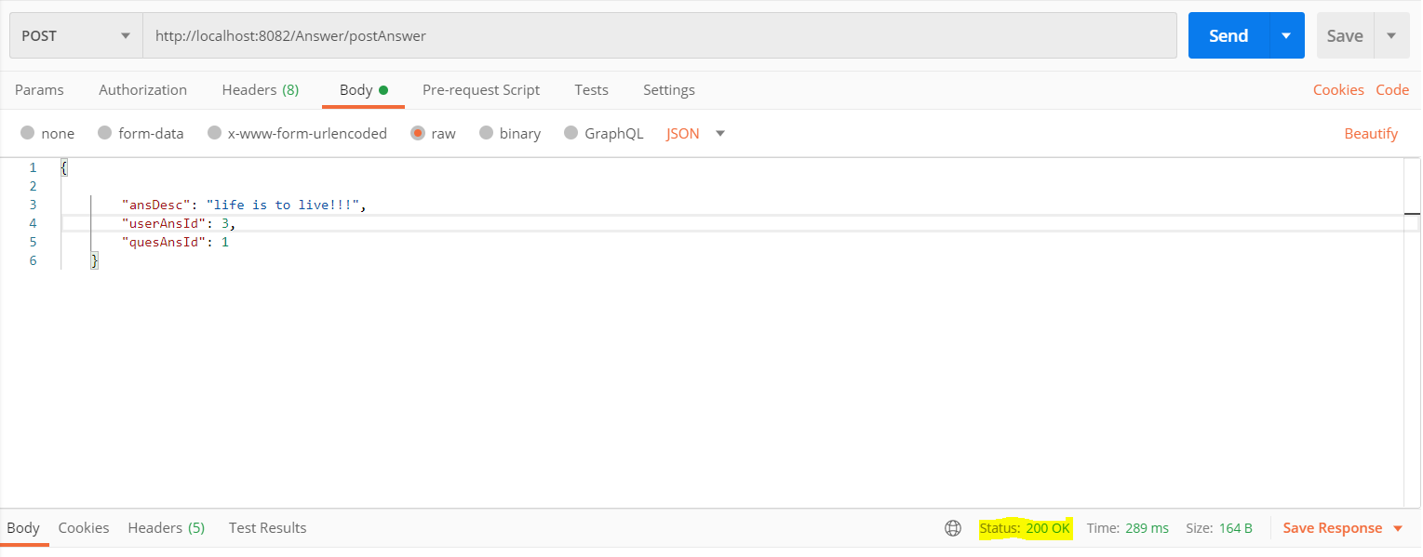

API’s

<http://localhost:8082/Question/AllQuestions>

<http://localhost:8082/Question/CreateQuestion>

{

        "title": "life!",

        "tags": null,

        "description": "Can we find happiness within ?",

        "userid": 3

}

<http://localhost:8082/Answer/AllAnswers>

<http://localhost:8082/Answer/postAnswer>

{

        "ansDesc": "life is to live!!!",

        "userAnsId": 3,

        "quesAnsId": 1

}

<http://localhost:8082/Answer/editAnswer>

<http://localhost:8082/Answer/deleteAnswer>